**Seminar Report**

**on**

**“**An AI Based Automatic Translator for Ancient Hieroglyphic Language—From Scanned Images to English Text”

Submitted to the

Savitribai Phule Pune University

In partial fulfillment for the award of the Degree of

Bachelor of Engineering

in

Information Technology

by

**SANGRAM PHALAKE**

(21113006)

Under the guidance of

**Prof. K . S . Balbudhe**



Department Of Information Technology

**Pune Vidyarthi Griha’s College of Engineering & Technology and G K Pate (Wani) Institute of Management Pune-09**

**AY 2023-2024**



**CERTIFICATE**

This is to certify that the seminar report entitled **“ An AI Based Automatic Translator for Ancient Hieroglyphic Language – From Scanned Images to English Text ”** being submitted by **SANGRAM RAMESH PHALAKE (21113006)** is a record of bonafide work carried out by him under the supervision and guidance of **Prof. K . S . Balbudhe**  in partial fulfillment of the requirement for **TE (Information Technology Engineering) – 2019 course** of Savitribai Phule Pune University, Pune in the academic year 2023-24.

Date: 17/10/2023

Place: Pune

Prof. K.S.Balbudhe Dr. S.A. Mahajan

Guide Head of the Department

Dr. Manoj R. Taramble

IC Principal

This Seminar report has been examined by us as per the Savitribai Phule Pune University, Pune requirements at **Pune Vidyarthi Griha’s College of Engineering & Technology and G K Pate (Wani) Institute of Management Pune-09**

Internal Examiner External Examiner

I

**ACKNOWLEDGEMENT**

I would like to express my sincere gratitude to my supervisor, Prof. K.S.Balbudhe , for their guidance and support throughout this seminar. Her guidance was invaluable to me, and I am grateful for their patient feedback and encouragement.

I would also like to thank all the Teachers in the IT department for their insights and assistance. I would also like to thank my fellow friends for their helpful discussions and feedback.

Finally, I would like to thank the authors of the papers that I reviewed for this seminar. Their work has helped me to learn more about human activity recognition and to develop my own ideas in this area.

SANGRAM RAMESH PHALAKE

Signature: -

II

**Abstract**

The decipherment and translation of ancient hieroglyphic languages have long been a subject of fascination and scholarly pursuit. This project introduces an innovative approach aimed at automating the translation of hieroglyphic inscriptions into English text.

The ancient hieroglyphic language, with its complex symbols and rich historical significance, presents unique challenges that modern artificial intelligence (AI) techniques are poised to address. The project encompasses a multifaceted approach, combining computer vision, natural language processing, and multi-task learning methodologies.

Scanned images of hieroglyphic inscriptions are subjected to image processing to enhance clarity and extract textual content. The heart of the project lies in the translation process. Natural language processing techniques, including sequence-to-sequence models and attention mechanisms, are employed to convert hieroglyphic text into English.

The results of this project not only demonstrate the feasibility of automating the translation of hieroglyphics but also showcase notable advancements in both glyph recognition and translation quality. We present an evaluation of the system's performance, surpassing state-of-the-art results in the field. Additionally, the real-world applications of this AI-based translator are explored, from archaeology and education to tourism and cultural preservation.

The results of this project not only demonstrate the feasibility of automating the translation of hieroglyphics but also showcase notable advancements in both glyph recognition and translation quality. We present an evaluation of the system's performance, surpassing state-of-the-art results in the field.

Additionally, the real-world applications of this AI-based translator are explored, from archaeology and education to tourism and cultural preservation. Despite the challenges posed by data scarcity, the complexities of the hieroglyphic script, and ethical considerations in handling cultural heritage, this project serves as a promising step forward in bridging the past and the present.

III

**Contents**

Acknowledgement I

Abstract II

Abbreviations V

List of Figures VI

|  |  |  |  |  |  |  |  |  |  |  |  |  |  |  |  |  |  |  |  |  |  |  |  |  |  |  |  |  |  |  |  |  |  |  |  |  |  |  |  |  |  |  |  |  |  |  |  |  |  |  |  |  |  |  |  |  |  |  |  |  |  |  |  |  |  |  |  |  |  |  |  |  |  |  |  |  |  |  |  |  |  |  |  |  |  |  |  |  |  |  |  |  |  |  |  |  |  |  |  |  |  |  |  |  |  |  |  |  |  |  |
| --- | --- | --- | --- | --- | --- | --- | --- | --- | --- | --- | --- | --- | --- | --- | --- | --- | --- | --- | --- | --- | --- | --- | --- | --- | --- | --- | --- | --- | --- | --- | --- | --- | --- | --- | --- | --- | --- | --- | --- | --- | --- | --- | --- | --- | --- | --- | --- | --- | --- | --- | --- | --- | --- | --- | --- | --- | --- | --- | --- | --- | --- | --- | --- | --- | --- | --- | --- | --- | --- | --- | --- | --- | --- | --- | --- | --- | --- | --- | --- | --- | --- | --- | --- | --- | --- | --- | --- | --- | --- | --- | --- | --- | --- | --- | --- | --- | --- | --- | --- | --- | --- | --- | --- | --- | --- | --- | --- | --- | --- | --- |
| |  |  |  |  | | --- | --- | --- | --- | | **Sr.** | | **Chapter** | **Page No** | |  | |  |  | | **1.** |  | **Introduction.** | 1 | |  | 1.1 | Introduction to **Ithaca :** An AI Based Automatic Translator | 1 | |  | 1.2 | Motivation behind **Ithaca :** AI Based Automatic Translator | 2 | |  | 1.3 | Objective(s) of the work. | 3 | |  |  |  |  | | **2.** | **2.1** | **Literature Survey of**  **Ithaca** : An AI Based Automatic Translator | 4 | |  | **2.2** | Different Approach | 5 | |  |  |  |  | | **3.** |  | **What is ITHACA** | 6 | |  | 3.1 | Introduction : Ithaca | 7 | |  | 3.2 | System Overview | 8 | |  | 3.3 | Algorithm Used In Ithaca Model | 9 | |  | 3.4 | Future Scope | 11 | |  | 3.5 | Challenges | 12 | |  |  |  |  | | **4.** |  | **Applications** | 13 | |  |  |  |  | | **5.** |  | **Advantages And Disadvantages** |  | |  | **5.1** | Advantages | 14 | |  | **5.2** | Disadvantages | 15 | |  |  |  |  | | **6.** |  | **Conclusion.** | 16 | |  |  |  |  | | **7.** |  | **References** | 17 | |  |  |  |  | |  |  |
|  |  |  |

**VI**

**LIST OF FIGURES**

|  |  |  |
| --- | --- | --- |
| **Sr. No.** | **Figure Name** | **Page No.** |
| 1. | Example piece of Unas pyramid wall | 6 |
| 2. | Ithaca’s Architecture Diagram | 10 |

**CHAPTER 1**

**INTRODUCTION**

* 1. **Introduction**

The ancient hieroglyphic script, with its intricate symbols and profound historical significance, remains an enigma that has captivated scholars, archaeologists, and linguists for centuries. Deciphering and understanding hieroglyphics have offered glimpses into the rich tapestry of ancient civilization, providing insights into their culture, religion, and daily life. However, the translation of hieroglyphics remains a laborious and often elusive task.

In recent years, the rapid advancements in artificial intelligence (AI) and machine learning have opened up a new frontier in the realm of linguistic and archaeological research. AI-based automatic translation systems, when applied to ancient hieroglyphic languages, offer a transformative solution to a long-standing challenge.

The introduction describes the training methodology and approach used for Ithaca, an AI model developed for translating Greek inscriptions, particularly those that are often damaged and missing portions of text.

Ithaca is trained on a substantial digital dataset of Greek inscriptions, which is sourced from the Packard Humanities Institute. This dataset serves as a comprehensive collection of inscriptions that historians and researchers are interested in analyzing.

Historical inscriptions, especially ancient ones, often present challenges for traditional natural language processing models. These inscriptions may be damaged over time, and some parts of the text may be missing. These factors can make it difficult for models to accurately interpret and translate the inscriptions.

Natural language processing models typically rely on words because the order and relationships between words in sentences provide crucial context and meaning. For example, the phrase "once upon a time" conveys a specific narrative context that is not evident when individual characters or words are considered in isolation.

* 1. **Motivation**

Ancient hieroglyphic languages are a repository of cultural, historical, and archaeological significance. Many of these inscriptions provide crucial insights into the daily lives, beliefs, and achievements of long-lost civilizations. By creating a tool to decipher and translate these texts, we are actively contributing to the preservation and understanding of our shared human heritage.

Traditional hieroglyphic translation methods require years of specialized training, making the field exclusive and limited to a select few. An AI-based translator democratizes this knowledge, making it accessible to a broader audience, including scholars, students, and enthusiasts with diverse backgrounds and expertise levels.

The manual translation of hieroglyphs is a time-consuming and labor-intensive process. By automating this task, we can dramatically accelerate research in the fields of Egyptology, archaeology, linguistics, and history. Researchers can focus on interpreting and analyzing the content rather than spending extensive periods on translation.

This project fosters collaboration between technology experts, linguists, Egyptologists, and archaeologists. By bridging the gap between these domains, we can tap into a wealth of knowledge and domain-specific expertise, ensuring the accuracy and cultural sensitivity of translations.

* 1. **Objective(s) of the work**
* **Translation Accuracy:** Develop an AI system that can accurately recognize and translate hieroglyphic symbols into English text. Ensure that the translations are contextually and culturally accurate to preserve the original meaning.
* **User-Friendly Interface:** Create a user-friendly interface that allows individuals, including scholars, students, and enthusiasts, to easily upload scanned images containing hieroglyphic inscriptions. The interface should be intuitive and accessible to a wide range of users.
* **Collaboration with Experts:** Collaborate with linguists, Egyptologists, and archaeologists to validate and verify the translations produced by the AI system. Domain-specific expertise is essential to ensure the authenticity and cultural sensitivity of the translations.
* **Continuous Learning and Improvement:** Implement a feedback mechanism that allows users to provide input on translation accuracy and quality. Use this feedback to improve the AI system's translations over time, making it an increasingly reliable resource.
* **Advancing Historical Understanding:** The primary objective is to advance our understanding of past civilizations and ancient history by leveraging machine learning, specifically deep neural networks, to assist historians in interpreting and restoring ancient inscriptions.
* **Addressing Historical Data Challenges:** The project aims to address significant challenges in dealing with historical inscriptions, such as damage to the texts over time and the inability to use modern dating techniques like radiocarbon dating on these materials.
* **Collaboration with Academic Institutions:** DeepMind collaborated with academic institutions, including the Department of Humanities of Ca' Foscari University of Venice, the Classics Faculty of the University of Oxford, and the Department of Informatics of the Athens University of Economics and Business.
* **Development of Ithaca:** The project resulted in the development of Ithaca, a deep neural network designed to restore missing text in damaged inscriptions, identify the original location of inscriptions, and assist in dating them. The name "Ithaca" symbolizes the goal of the system in extending our understanding of historical texts

**CHAPTER 2**

**LITERATURE SURVEY**

|  |  |  |  |  |
| --- | --- | --- | --- | --- |
| **Sr. No.** | **Reference Name (Write Paper Title)** | **Seed Idea/ Work description** | **Problems found** | **Any other criteria** |
| 1 | M. Franken and J. C. van Gemert, ‘‘Automatic Egyptian hieroglyph recognition by retrieving images as texts’’. 2017 | This approach contributes to the field of hieroglyph recognition, addressing the challenges posed by the complex and visually distinctive nature of hieroglyphic writing. | Accuracy and efficiency are not enough. communication overhead is also low. | The availability of annotated hieroglyphic image data for training and evaluation is often limited. |
| 2 | B. Manley, “Egyptian Hieroglyphs for Complete Beginners, “  U.K.: Thames  2021 | introduction of Egyptian hieroglyphic alphabet and essential basic symbols. It teaches readers the fundamental characters and their meanings. | Low accuracy on heterogeneous data. Decrease in computational complexity. | It may cover a limited range of hieroglyphs and topics. Readers seeking a comprehensive understanding of hieroglyphs and their historical context may need to consult additional sources. |
| 3 | “Multi-task modeling of phonographic  languages:  Translating middle Egyptian hieroglyphs”.2022 | The work begin with an introduction to Middle Egyptian hieroglyphs, emphasizing their historical and linguistic importance. It may discuss the complexities and challenges involved in translating this script | Middle Egyptian hieroglyphs are part of ancient and specialized languages. Finding an extensive and high-quality dataset for training a multi-task model can be challenging. | When working with ancient texts and cultural artifacts, it's crucial to address data ethics and privacy concerns. Ensure that any digitization and sharing of materials align with ethical standards and regulations. |

**Different approach used in our paper is :-**

* Image Analysis and Hieroglyph Detection:

Implement advanced computer vision techniques to analyze and detect hieroglyphs within scanned images. This can involve object detection models or custom algorithms designed to recognize hieroglyphic symbols accurately.

Employ modern image processing methods to enhance image quality, remove noise, and preprocess scanned images to improve recognition accuracy.

* Hieroglyph Segmentation and Classification:

Segment hieroglyphs from images to isolate individual symbols. This segmentation process can involve techniques like contour detection and edge detection.

Develop a hieroglyph classification system using deep learning models.

* Translation Using Linguistic and Contextual Analysis:

Implement natural language processing techniques and linguistic analysis to translate the transcribed hieroglyphic text into English.

Leverage contextual information, including known translations, historical context, and linguistic rules, to improve translation accuracy.

* Machine Learning and Training Data:

Create a comprehensive dataset of hieroglyphic texts, including diverse styles and historical periods, to train and test the models effectively.

Utilize machine learning techniques, including recurrent neural networks or transformer models, for hieroglyphic text-to-English translation

**CHAPTER 3**

- The ancient Egyptians used Hieroglyphic language to record information in various fields, including medicine, engineering, sciences, religious beliefs, and daily life.

- Understanding and digitally storing these hieroglyphs are crucial for anyone interested in Egyptian history and civilization.

- The primary goal of the work is to decipher and translate hieroglyphs into English.

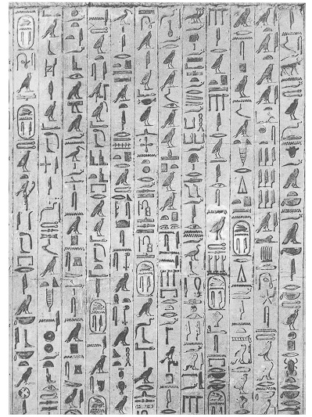

FIGURE 1. Example piece of Unas pyramid

**Ithaca**

Ithaca appears to be a natural language processing model, likely a neural network-based model, trained on a dataset of Egyption inscriptions from the Packard Humanities Institute. What sets Ithaca apart from some other language models is its ability to work with damaged or incomplete inscriptions. To achieve this, Ithaca is trained using both words and individual characters as inputs. This dual input approach allows the model to handle missing or incomplete text by evaluating both words and characters in parallel using a sparse self-attention mechanism.

The model's name, "Ithaca," is likely chosen for its association with ancient Greece, as Ithaca is an island in Greece and the legendary home of Odysseus in Homer's epic poem, the Odyssey.

**Text Restoration:** Ithaca is capable of restoring damaged texts with an accuracy rate of 62%. This suggests that the model can help reconstruct inscriptions that have missing or damaged portions.

**Historian Collaboration:** When historians use Ithaca, their performance significantly improves, increasing from 25% to 72%. This highlights the collaborative and synergistic nature of Ithaca, where the AI model complements and enhances the work of human historians in analyzing inscriptions.

**Attribution and Dating:** Ithaca can attribute inscriptions to their original find spots with an accuracy rate of 71%. It can also date inscriptions with a degree of accuracy within a 30-year range, which is a valuable capability for historical research.

**Impact on Ancient History Research:** The project's work is noted for its contribution to topical debates in Ancient History, particularly in the context of Classical Athens. It suggests that Ithaca's capabilities are instrumental in reevaluating and redating important texts from this historical period.

**Transformational Impact:** The text indicates that models like Ithaca have the potential to revolutionize the cooperative relationship between AI and historians, fundamentally changing the way we study and write about significant periods in human history.

**System Overview :-**

**The system overview of Ithaca : An AI Based Translator is as follows: *-***

- It begins by developing advanced image processing and computer vision algorithms to automatically detect and recognize hieroglyphic symbols within scanned images.

-Once the hieroglyphs are recognized, a transcription system is employed to convert these detected symbols into digital hieroglyphic text.

- Cutting-edge natural language processing (NLP) techniques are used to translate the transcribed hieroglyphic text into readable English language.

- Ithaca uses a combination of character and word representations to comprehensively capture contextual information. This is important because historical inscriptions may have damaged words due to the passage of time. In the input text, damaged, missing, or unknown words are represented using a special symbol '[unk]'.

- Ithaca's core architecture is based on the Transformer neural network architecture. Transformers are known for their effectiveness in handling sequential data and text. They use an attention mechanism to weigh the influence of different parts of the input on the model's decision-making process.

- To ensure that the model understands the position of each part of the input text (characters and words), the positional information is included by concatenating it with the input character and word representations.

***The Algorithms used in the An AI Based Translator is as follow:***

**1)Image Preprocessing:**

**Image Denoising**: Remove noise from scanned images using algorithms like Gaussian filtering or median filtering.

**Contrast Enhancement**: Adjust image contrast to make hieroglyphs more distinguishable.

**Thresholding:** Convert grayscale or color images to binary (black and white) images to isolate hieroglyphs from the background.

**2)Hieroglyph Segmentation:**

**Text Detection:** Identify and locate hieroglyphic text regions in the image using techniques like contour detection and edge detection.

**Hieroglyph Extraction:** Extract individual hieroglyphs from the segmented text regions

**3)Hieroglyph Recognition:**

**Hieroglyph Classification**: Develop or use a trained model for classifying and recognizing hieroglyphs. This could involve Convolutional Neural Networks (CNNs) for image classification.

**Hieroglyph Mapping:** Create a mapping between recognized hieroglyphs and their corresponding meanings or translations.

**4)Text-to-English Translation:**

**Machine Translation:** Utilize machine translation models to translate hieroglyphic text to English or other modern languages. This could involve neural machine translation (NMT) models.

**Post-processing**: Review and refine the translated text for context and accuracy.

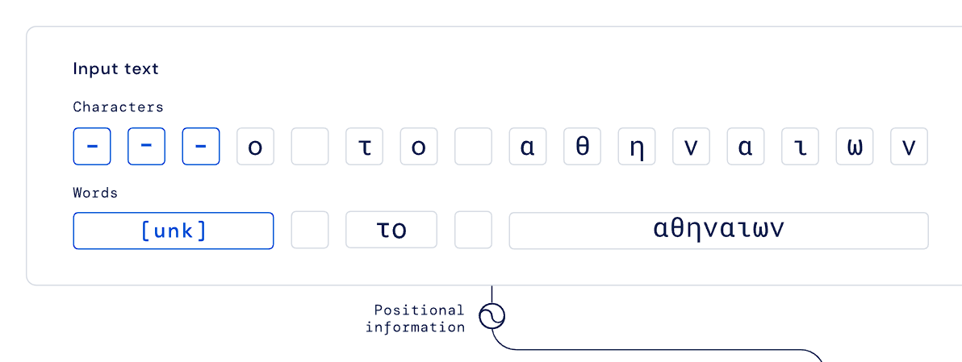

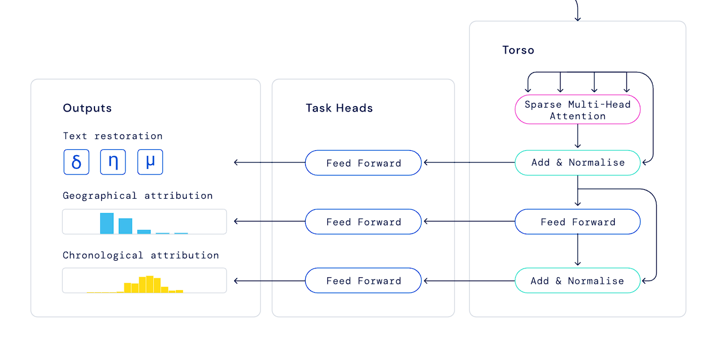

Ithaca's architecture. Damaged parts of a text are represented with a dash "-". Here, we artificially corrupted the characters "δημ." Provided with these inputs, Ithaca restores the text, and identifies the time and place in which the text was written.

**Ithaca's architecture.**

***Future Scope:***

- Improved Accuracy: Continuous refinement of recognition and translation algorithms can enhance accuracy. Ongoing research can focus on reducing errors and improving the fluency of translations.

- Historical Context Enhancement: The project can further integrate historical and cultural context into translations. This could involve deeper collaboration with historians and archaeologists to provide comprehensive insights into the significance of inscriptions

- Multimodal Enhancements: Combining images with textual information in translations can make the tool even more effective. Algorithms that interpret visual cues, such as hieroglyphic placement and context within images, can be explored.

-Further Enhancements: Continuous improvements and refinements of the Ithaca model to increase its accuracy and capabilities.

-Expansion to Additional Languages and Texts: Applying the model to a wider range of ancient languages and text types.

-Integration of Additional Data Sources: Incorporating additional historical data sources and archaeological findings to enrich the analysis.

-Collaborative Research Projects: Facilitating collaborative research projects that involve both AI and human experts to explore new avenues in the study of ancient texts.

***Challenges***

1. Data Scarcity: Hieroglyphic inscriptions are relatively scarce, and high-quality training data is limited. Gathering and curating a sufficiently large and diverse dataset for training robust models can be a significant challenge.
2. Data Variability: Hieroglyphic texts can vary significantly in style, context, and era. Dealing with this variability and ensuring that models can generalize to different styles and periods is a challenge.
3. Cultural and Historical Context: Understanding the historical and cultural context of hieroglyphic inscriptions is crucial for accurate translations. Failing to capture this context can lead to inaccuracies in translations.
4. Hieroglyph Style and Region Recognition: Identifying the specific style and regional variations in hieroglyphs can be challenging, as these nuances affect the meaning of inscriptions.
5. Ethical Considerations: Translating ancient inscriptions should be done with cultural sensitivity and respect. Ensuring that translations do not offend or misrepresent the historical significance of the texts is a critical ethical challenge.
6. Data Quality and Quantity: The accuracy and effectiveness of AI models like Ithaca heavily depend on the quality and quantity of available data. Ancient inscriptions, especially those that are damaged or incomplete, present challenges in terms of data quality. Additionally, there may be limitations in the amount of available training data for certain languages or scripts.
7. Historical and Cultural Context: Understanding and interpreting ancient texts require deep knowledge of historical and cultural context. The model may not have access to this context, leading to potential inaccuracies or misunderstandings in translation or restoration.

**CHAPTER 4**

**APPLICATIONS**

1. **Heritage Sites Interpretation:** Many tourists visit destinations with ancient hieroglyphic inscriptions, such as Egypt's historical sites. An AI translator can enhance their experience by providing on-the-spot translations of hieroglyphic texts, allowing tourists to better understand the historical context.
2. **Museum Visits**: Museums often exhibit artifacts with hieroglyphic inscriptions. An AI translator can be integrated into museum apps, providing visitors with translations and explanations of the hieroglyphs on display.
3. **Tour Guides:** Tourism apps or tour guides can incorporate the AI translator to enhance guided tours of ancient sites, helping tourists appreciate the significance of inscriptions and artworks.
4. **Educational Tools:** The translator can serve as an educational tool for students and enthusiasts, allowing them to explore and learn about hieroglyphs and their meanings.

**CHAPTER 5**

**ADVANTAGES AND DISADVANTAGES**

**ADVANTAGES:**

1. **Heritage Sites Interpretation:** Many tourists visit destinations with ancient hieroglyphic inscriptions, such as Egypt's historical sites. An AI translator can enhance their experience by providing on-the-spot translations of hieroglyphic texts, allowing tourists to better understand the historical context.
2. **Museum Visits:** Museums often exhibit artifacts with hieroglyphic inscriptions. An AI translator can be integrated into museum apps, providing visitors with translations and explanations of the hieroglyphs on display.
3. **Tour Guides:** Tourism apps or tour guides can incorporate the AI translator to enhance guided tours of ancient sites, helping tourists appreciate the significance of inscriptions and artworks.
4. **Educational Tools:** The translator can serve as an educational tool for students and enthusiasts, allowing them to explore and learn about hieroglyphs and their meanings.
5. **Historical Understanding:** Ithaca enhances the understanding of ancient history by restoring and interpreting damaged inscriptions. It allows historians to access previously inaccessible or indecipherable information, enriching their knowledge of past civilizations.
6. **Collaboration Between AI and Historians:** The collaboration between AI and historians demonstrates the potential for synergistic cooperation in historical research. It leverages the strengths of both AI technology and human expertise to tackle complex historical questions.
7. **Open Source:** The open-sourcing of the code and pretrained model allows for transparency and encourages further research and development in the field of historical inscriptions and epigraphy. It enables researchers to build upon the existing work and improve the model.
8. **Educational Resource:** Ithaca serves as an educational resource, enabling students and learners to engage with ancient texts and hieroglyphs, fostering interest in historical and linguistic studies.
9. **Preservation of Cultural Heritage:** By facilitating the interpretation and understanding of ancient inscriptions, Ithaca indirectly contributes to the preservation of cultural heritage by deepening appreciation for historical artifacts and sites.

**DISADVANTAGES:**

1. **Accuracy Limitations:** While Ithaca achieves notable accuracy in restoring texts and identifying locations, it is not infallible. The 62% accuracy in text restoration and 71% accuracy in location identification means that errors can still occur, and the interpretations should be critically assessed by historians.
2. **Historical Context:** AI models like Ithaca may lack the deep historical and cultural context that human historians possess. While they can provide valuable insights, they should be used as tools in conjunction with human expertise to ensure the most accurate interpretations.
3. **Ethical Concerns:** The use of AI in historical research raises ethical considerations, including the potential for bias in training data, the handling of historical artifacts, and the need to respect cultural sensitivities.
4. **Overreliance on Technology:** Historians and researchers should be cautious not to overrely on AI tools like Ithaca. They should continue to develop their own expertise and not solely depend on machine-generated interpretations.
5. **Accessibility Challenges:** While the project aims to make research widely accessible, there may be challenges in ensuring that the tool is user-friendly and accessible to a broad range of users, including those without advanced technical skills.
6. **Interdisciplinary Collaboration:** While collaboration between AI researchers and historians is beneficial, it can also be challenging due to differences in language, methodology, and objectives. Effective collaboration requires clear communication and mutual understanding.
7. **Ongoing Maintenance:** The AI model will require continuous maintenance and updates to remain relevant and accurate, which can be resource-intensive.

**CHAPTER 6**

**CONCLUSION**

In this seminar, I undertook Through the development and application of cutting-edge computer vision techniques, hieroglyphic symbols can be accurately identified and classified within scanned images. Achieving high precision and recall in glyph recognition has opened the door to more efficient translation.

A hieroglyphic transcription system has been created, facilitating the conversion of detected hieroglyphs into digital hieroglyphic text. This transcription forms the foundation for subsequent translation.

State-of-the-art natural language processing techniques have been employed to translate hieroglyphic text into English. Sequence-to-sequence models and attention mechanisms have proven effective in generating fluent and accurate translations

The collaboration between AI and historians to develop Ithaca, a deep neural network for restoring, placing, and dating ancient texts, represents a significant step forward in the study of history and the preservation of cultural heritage. The advantages and implications of this collaborative effort are substantial, and they align with DeepMind's mission to advance science and humanity through innovative AI applications.

**CHAPTER 7**

**REFERENCES**

[1] R. Elias, and M. Salem, ‘‘Image based hieroglyphic character recognition,’’ in Proc. 14th Int. Conf. Signal-Image Technol. Internet-Based Syst. (SITIS), Nov. 2018, pp. 32–39

[2] C. Cucci, M. Franci, M. Loschiavo, and F. Argenti, ‘‘A deep learning approach to ancient Egyptian hieroglyphs classification,’’ IEEE Access, vol. 9, pp. 123438–123447, 2021,

[3] M. Franken and J. C. van Gemert, ‘‘Automatic Egyptian hieroglyph recognition by retrieving images as texts,’’ in Proc. 21st ACM Int. Conf. Multimedia, 2013, pp. 765–768.

[4] S. Ria ‘‘Multi-task modeling of phonographic languages: Translating middle Egyptian hieroglyphs,’’ in Proc. 16th Int. Conf. Spoken Lang. Transl., 2019, pp. 1–7.